HireVue for Finance: How to Prepare for a Recorded Interview
Meta description: HireVue for finance candidates: which banks use the recorded interview, what happens on screen, who watches the video, what they ask, and a one-week prep plan.

HireVue is the recorded, one-way video interview most large banks use as the first round for Summer Analyst and full-time campus hiring. Goldman Sachs has used it for first-round campus interviews since 2016, and about one in three of its summer analyst applicants got one in 2019. A typical bank HireVue is three to six questions, 30 seconds to prepare each one, about two minutes to answer, and a deadline of two to seven days. In this article, I lay out which firms use it, what happens on screen, who watches the video, what they ask, and how to prepare in the week you have.

Is HireVue scored by AI?
At the banks, people watch the video. Goldman says all of its video interviews are reviewed by trained human recruiters and colleagues across the firm, "not through an algorithm." HireVue stopped analyzing faces in 2020. Where an employer buys HireVue's separate AI-scored assessment, the software scores a transcript of what you said, and no bank has publicly confirmed that it uses that product. Section 3 has the detail, including the Illinois and New York City rules that require notice if a bank ever does.

Can you redo a HireVue question?
Sometimes, and the screen tells you before you start. The bank sets how many attempts you get per question, HireVue shows that number on a screen before the first question, and once you submit an answer you can't return to that question. Goldman has usually allowed one take. JPMorgan has usually allowed one retake, and prep guides say a retake replaces the first recording. [VERIFY: attempt settings at Goldman and JPMorgan for the Summer 2028 cycle] HireVue's support team can't reset an interview or add attempts; only the bank can.

1. Which banks use HireVue and which interview live
Most bulge brackets use a recorded round. Most elite boutiques don't.

The table below separates what a firm says on its own page or in a court record from what prep guides and candidates report, because the two aren't equally reliable and the settings change between cycles. Goldman Sachs and JPMorgan run a recorded HireVue before any live interview, while Evercore, PJT and Moelis interview live from the first round. Goldman switched its first-round summer and full-time analyst interviews to HireVue in 2016, per an HR Dive report from June of that year, and second rounds stayed in person. JPMorgan's one-way HireVue is on the public record in a federal appeals case reported by Courthouse News in July 2026.

Firm | Uses a recorded interview? | What candidates report | Source type
Goldman Sachs | Yes, HireVue, since 2016 | 3 to 6 questions, 30 seconds prep, 1:30 to 2:00 answers, usually one take, about a week to complete | Goldman's own post; HR Dive
JPMorgan | Yes, HireVue | 3 to 5 mostly behavioral questions, one optional retake, 7 days; invite often within hours | Federal court record (Courthouse News, July 2026); Glassdoor, September 2026
Morgan Stanley | Yes, HireVue (reported by prep guides) | 3 to 5 questions, 30 to 60 seconds prep, 90 seconds to 2 minutes, one retry that erases the first, 48 to 72 hours | Prep guides; Glassdoor
Bank of America | Yes, HireVue (reported by prep guides) | 5 to 7 questions, about 30 seconds prep, 2 to 3 minutes, about two days; 2 or 3 bankers score each candidate | Prep guide
Citi | Yes, HireVue (reported by prep guides) | 3 to 6 questions, 30 seconds prep, 1 to 3 minutes, assume one take, about 48 hours, one news or markets prompt | Prep guide
Barclays | No video step on its current official page | Application, two initial assessments, assessment centre | Barclays' own page
UBS | Yes, HireVue (reported by prep guides) | 6 to 8 questions, about 90 seconds prep, about 2 minutes, no re-record | Prep guide
Deutsche Bank | Yes for some roles, a pre-recorded video interview, platform not named | Some roles in the UK, Germany and APAC; invite about six weeks after applying | Deutsche Bank's own page
Wells Fargo | Yes, HireVue (reported by prep guides) | 4 to 6 prompts; window from the next day to about a week | Prep guide
RBC | Yes, HireVue (reported by prep guides) | 4 to 5 questions, 30 seconds prep, 90 to 120 seconds | Prep guide
Jefferies | Online test, then phone or HireVue (reported by prep guides) | SHL test first; 20 to 30 minute first round with junior bankers | Prep guide
Evercore | No, live only in the US (reported by prep guides) | No online test or recorded screen in the US loop; UK and EMEA have one | Prep guide
Lazard | Recorded, mainly UK and Europe (reported by prep guides) | 3 to 5 motivation questions, about 2 minutes, no retakes; US candidates usually go to a live first round | Prep guide
PJT Partners | No; a written Suited assessment, then live (reported by prep guides) | Every interview is live | Prep guide
Moelis | No; a written Suited assessment, then live (reported by prep guides) | No recorded video at any point | Prep guide
BlackRock | Yes, a recorded pre-interview assessment | Applications aren't considered until it's done; prep guides report 3 minutes prep, 90-second answers, no retakes | BlackRock's early careers page
Vanguard | Yes, HireVue after online games (reported by prep guides) | Background and interest questions | Prep guide
Fidelity | HireVue for some roles (reported by prep guides) | Replaces a live behavioral round for some roles | Prep guide
Citadel | No, live | 45 to 60 minute remote first round on video, with a CoderPad link sent beforehand | Citadel's own page
McKinsey | No; the Solve game, then live | A gamified problem-solving assessment, no recorded video | McKinsey's own page

[VERIFY: question counts, prep and answer times, attempts and windows for each firm against current candidate reports before publish; these settings change by cycle and by division]

Two patterns in the table are worth knowing before you apply. Goldman, JPMorgan, Bank of America, Citi and Morgan Stanley all run a recorded round. Goldman's post says the firm interviewed students from 643 schools in 2015 and from 1,250 schools for the incoming class it described in January 2020, and over the same years the share of summer analyst applicants who got a video interview rose from fewer than one in five to about one in three.

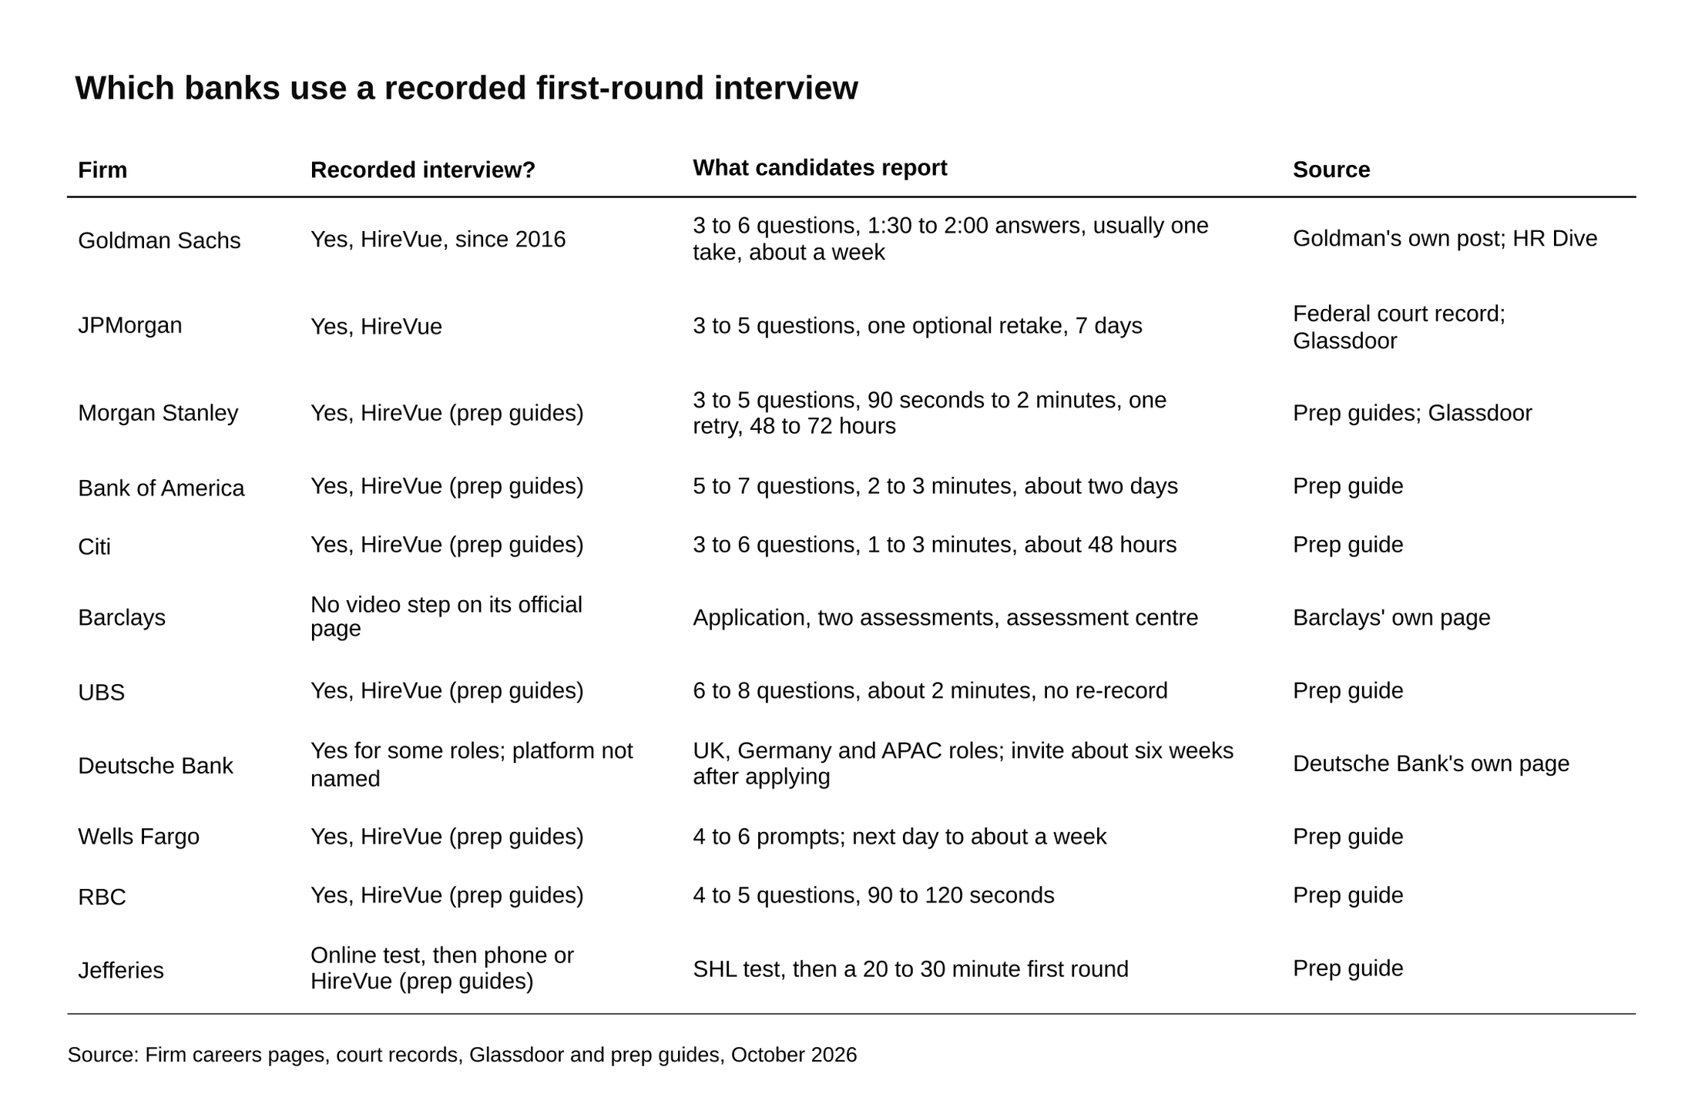
Goldman, JPMorgan, Morgan Stanley, Bank of America and Citi all run a recorded round.
Source: Firm careers pages, court records, Glassdoor and prep guides, October 2026.

The elite boutiques run smaller processes and skip the recording. Prep guides describe Evercore's US loop as two live 30-minute interviews with no online assessment, and PJT and Moelis as a written Suited questionnaire (personality, values, and a few academic and extracurricular questions, all typed) followed by live interviews. Lazard is the exception, and mainly outside the US.

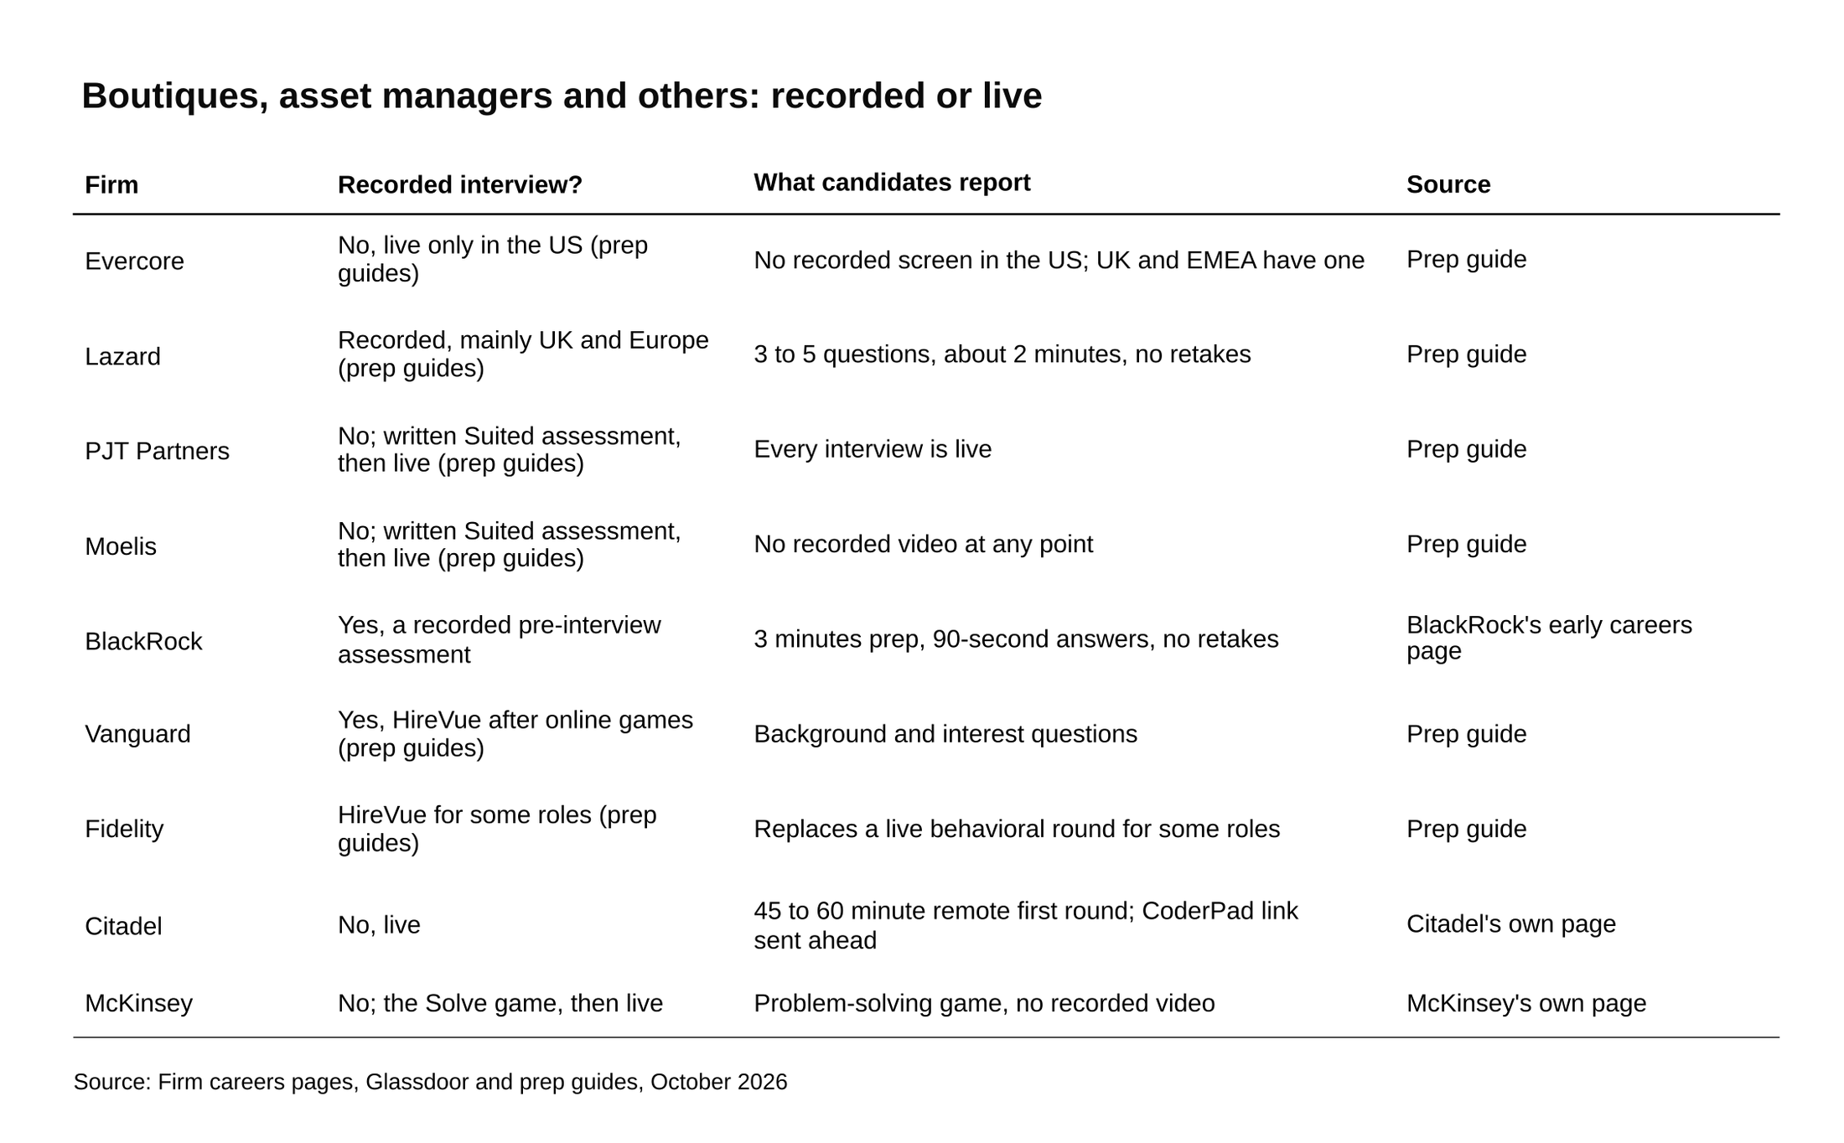
Evercore, PJT and Moelis interview live from the first round; Lazard records mainly outside the US.
Source: Firm careers pages, Glassdoor and prep guides, October 2026.

Two of the official pages say less than the prep guides do. Barclays' application page lists an application, two "initial assessments" and an assessment centre, with no video interview named. [VERIFY: Barclays' process page before publish; older prep guides describe a video step] Deutsche Bank's application page says that "for some roles in our UK, German and APAC regions, this will be a pre-recorded video interview," and that it takes "approximately 6 weeks" from application to the interview invitation. If your bank isn't in the table, the invitation will name the platform, and the first page of the interview shows you the question count and length before you commit to anything.

2. What happens on screen, step by step
The sequence is the same at every bank, because HireVue builds it and the bank only chooses the questions, the clocks and the attempts. This walk-through follows HireVue's "Getting Started with Your On-Demand Interview" article and the related articles in its Candidate Help Center. [VERIFY: restore the Help Center article links at publish after a click-test; the link checker couldn't reach hirevuesupport.zendesk.com]

You won't see a question until its prep clock starts, and the answer submits itself when the response clock hits zero. Everything before that first question is setup, and you can do all of it days before you record.

- The invitation email. The bank sends it, with a button labeled "Practice or Interview." HireVue's "When is My Interview Due" article says the invitation email is the best place to look for timing: it shows either an exact due date with a time zone or a window such as "within 48 hours." When that passes, "the link will expire." HireVue's support team "cannot personally extend a deadline or reset an interview"; only the bank can send a new invitation.

- The requirements page. In HireVue's words, "the first page you see will walk you through the requirements of your interview." This page also carries the accommodations link ("Click here to request accommodations"), which is where you ask for extra time on timed questions. More on that in the FAQ.

- The company, the role, and the shape of the interview. The next pages show the bank's name, the position, "the number and types of questions you'll be asked to answer," and "an estimated length of time to complete the interview." You still don't see the questions. If the page says five questions and 12 minutes, you now know your total recording time before you've said a word.

- Terms and conditions. You have to accept them to continue.

- An optional intro video from the bank. HireVue's article is explicit that "this does not mean that you've entered your interview."

- The equipment check. The browser asks for camera and microphone access. You confirm you can see yourself and that the microphone meter moves when you talk. This is the moment to notice that your lamp is behind you.

- The practice choice. You see "Try a practice question" or "Continue without practicing." Take the practice.

- The attempts screen. A screen shows how many attempts you get per question, and in HireVue's words "the number of attempts you will have is set up by the hiring company." Read the number. It's the only time HireVue tells you.

- Practice, if you chose it. HireVue's Practice FAQ says "there are three generic practice questions that you can redo as many times as you need," that "there's no limit," and that "practice questions are never uploaded or submitted to anyone, nor can they ever be viewed by anyone except yourself." You can replay a practice answer. You can't replay a real one.

- Start Now. Until you press this, you can close the browser and come back later through the same link. After it, the clocks run.

- Each question. A prep countdown starts and the words "Not Recording" appear. You can press "Start Recording" to skip the rest of the prep time. A three-second countdown follows, then the response countdown. Press "Done Answering" to stop early, otherwise "your recording will automatically submit after the allotted response time has run out." There is no pause button.

- A dropped connection. Reopen the invitation link. HireVue's "Preparing for your Interview" article says "you will be returned to your last unanswered question." If the connection dropped in the middle of an answer, that answer may already have submitted as it was.

- Finishing. Your responses upload and the bank decides what happens next. HireVue has no access to your application status, so questions about next steps go to the bank's recruiter.

Two of these steps decide more than the rest.

Step 3 tells you the total length, so you can plan your energy: a six-question Goldman HireVue at two minutes each is 12 minutes of talking, and a Bank of America one at seven questions and three minutes each can run past 20. Step 8 tells you whether a bad take is survivable. Treat one attempt as the default and anything more as a gift.

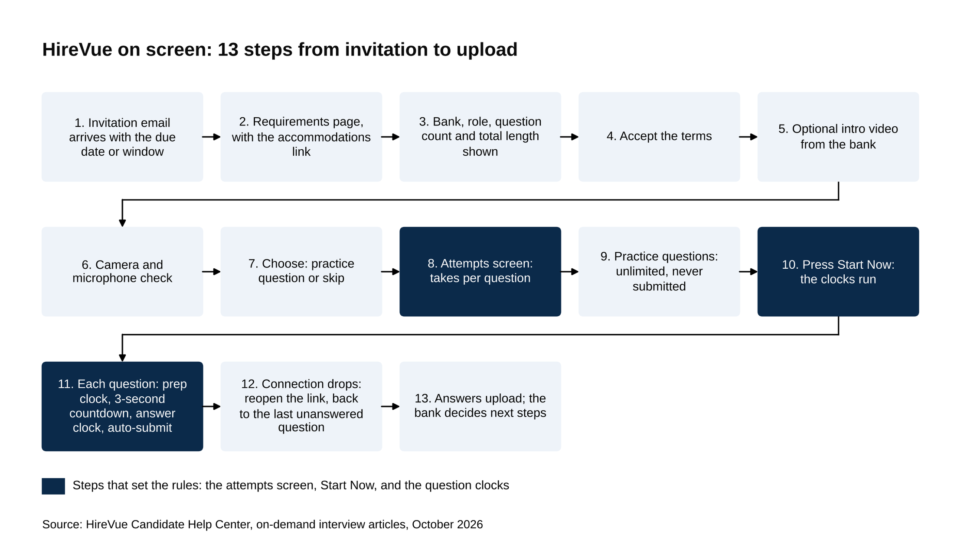
Steps 1 to 9 are setup you can do days early; the clocks start at step 10, Start Now.
Source: HireVue Candidate Help Center, on-demand interview articles, October 2026.

3. Who watches the video and what they score
At Goldman, people.

The firm's own careers post, dated January 28, 2020, says a "pre-recorded video interview" goes to "selected candidates" and that all of them are "reviewed by trained human recruiters and colleagues across our firm," not through an algorithm. Two years earlier, Goldman recruiters told eFinancialCareers the videos weren't reviewed "by robots or anything like that."

At Bank of America, a prep guide reports that most candidates are scored by two or three bankers who then meet as a group to decide who advances, and that the HireVue cuts the shortlist roughly in half. [VERIFY: Bank of America reviewer process; prep-guide report, no primary source] That is the shape to assume everywhere: a junior banker with a queue of videos, a rating scale, and a reason to be quick.

What's on that banker's screen matters for how you answer. HireVue gives reviewers tools to "review interviews or key moments, apply consistent ratings, and share recordings," and its video interviewing page describes transcripts, highlights, summaries and talk-time metrics alongside the video. A reviewer may read your answer before watching it, or skip to the middle. An answer with a clear first sentence and a stated result survives that. One that warms up for 40 seconds doesn't.

HireVue stopped analyzing faces in March 2020, and the outside audit it commissioned found the visual data was contributing about 0.25 percent of what its models used to rate candidates. HireVue announced the change in January 2021, and then-CEO Kevin Parker told SHRM, "We're primarily assessing the candidate's answer to the questions." Fortune reported the 0.25 percent figure and that the auditors flagged accents and very short answers as areas to watch. The practical reading for a candidate: your expression isn't being scored by software, and very short answers are the thing the auditors worried about, so speak in full sentences and use the time.

Where AI scoring exists, it reads words. HireVue's assessment science paper says interview responses "are transcribed from speech to text" and scored on the language in the transcript, that a transcription the software isn't confident in triggers an "Insufficient Data Error" flagged "for manual review," and that faces and tone aren't inputs. That scoring only runs where an employer buys HireVue's Assessments product on top of the plain recorded interview, and no bank has publicly confirmed using it. If one ever does, Illinois' Artificial Intelligence Video Interview Act (in force since January 1, 2020) requires the employer to tell you, explain what the AI evaluates, and get your consent before the interview. New York City's Local Law 144 (enforced since July 5, 2023) requires at least 10 business days' notice before an automated tool is used on you and a published summary of an outside bias audit.

4. The questions banks ask
Five kinds show up, in roughly this order of frequency: why this firm and division, a behavioral story, a news or markets prompt, a situational judgment question, and, occasionally, a technical one.

The first two fill most of the slots at every bank.

Motivational questions come first. Goldman's 2018 set, as recruiters described it to eFinancialCareers, was mostly behavioral plus one division-specific question, and the motivational prompts were "Why do you want to work at Goldman Sachs? Why investment banking?" and "Why this particular division?" Securities candidates were asked about an asset class they're interested in. Our post on Goldman's HireVue questions works through 15 of them.

Behavioral questions carry the rest. Goldman's 2018 list included your hardest problem, a time you took initiative on a team, a conflict with someone senior, and your greatest strength. The JPMorgan candidate who posted on Glassdoor in September 2026 got three questions, mostly behavioral. Deloitte's version, per Lawrence University's 2023 career center guide, asked for a challenge overcome, a project and its results, and strengths and weaknesses. The same ten or so prompts repeat across firms, and our 30 behavioral interview examples cover the full set. Build five stories (a team, a failure, a conflict, a time you led, a time you worked from data to a decision) and nearly every behavioral prompt maps to one.

Candidates at JPMorgan, Citi, Bank of America and Morgan Stanley have all reported a HireVue question about a recent news story or trend that affects the division, so pick your story before you open the link. A JPMorgan candidate's September 2026 Glassdoor review lists "Tell us about a recent piece of news that you read about that affects the business division you are applying to and our clients." A prep guide's Citi examples are "Give me an example of business news you've read recently that could affect Citi," "What are you following in the markets?" and "Pitch me a stock." Bank of America's, from the same guide, is "Talk about a relevant news item you've seen and its impact on the markets." A Morgan Stanley Technology Summer Analyst candidate reported on Glassdoor in July 2025: "What do you think will be the biggest trends in the Technology space over the next 6-12 months?" and a prep guide's Morgan Stanley banking examples ask where the S&P 500 will be in 12 months. [VERIFY: news-prompt reports are from prep guides and Glassdoor, not firm pages]

The news answer has a shape, and 30 seconds isn't enough time to invent it. Pick one story in the division's world a week before you record. Learn the mechanism: who pays, who gets paid, what changes for the bank's clients. Then have one view and one question you'd ask the team. In the two minutes you say the story in one sentence, the mechanism in three or four, and the view at the end. Section 5 has the word budget.

Situational questions ask what you'd do, not what you did. HireVue's candidate FAQ lists situational judgment prompts as standard, and a prep guide's Wells Fargo example is "How would you handle a client request that conflicts with a deadline you've already committed to?" The scoring here is about sequence: who you tell first, what you ask, what you offer. Say the sequence.

Technical questions are rare in a HireVue and usually basic. Mergers & Inquisitions lists occasional three-statement, DCF, WACC and debt-versus-equity questions without naming banks, and prep guides list a DCF question and an LBO question without a dated candidate report of either at a named bank. If one comes, it's the kind you can answer in five or six sentences. Our walk-me-through-a-DCF post has the seven-step version; know it well enough to say the steps without the detail.

5. Using the 30-second prep and the two-minute answer
The prep clock isn't for writing.

In 30 seconds you can write four words, not four sentences, so the only useful thing to put on paper is the story's skeleton: a word for the situation, a word for the task, two for the action, one for the result. Lawrence University's HireVue guide gives the same advice: a quick bullet list, used only if you run dry. If you've built the five stories in Section 4, the 30 seconds is spent choosing one and writing its name.

A 90-second answer at a normal speaking pace of 100 to 125 words a minute is about 150 to 190 words, so plan for 150 and press "Done Answering" once you've said the result. Mergers & Inquisitions drills candidates at exactly that: 30 seconds of prep, 90 seconds of answer, about 150 words. For a two-minute slot the ceiling is 200 to 250 words, and the ceiling isn't the target. A 150-word answer that ends with a result reads better on a banker's screen than a 240-word answer that ends because the clock did.

Here's what 150 words looks like, split the way I'd split it. The situation gets two sentences, around 25 words: where you were, what was at stake. The task gets one, around 15: what you specifically had to do. The action gets most of the time, five or six sentences and around 85 words: the decisions you made and why, in order. The result gets one or two sentences, around 25 words, with a number in it if there is one. Then you stop. Said at a normal pace, that's about 70 to 90 seconds.

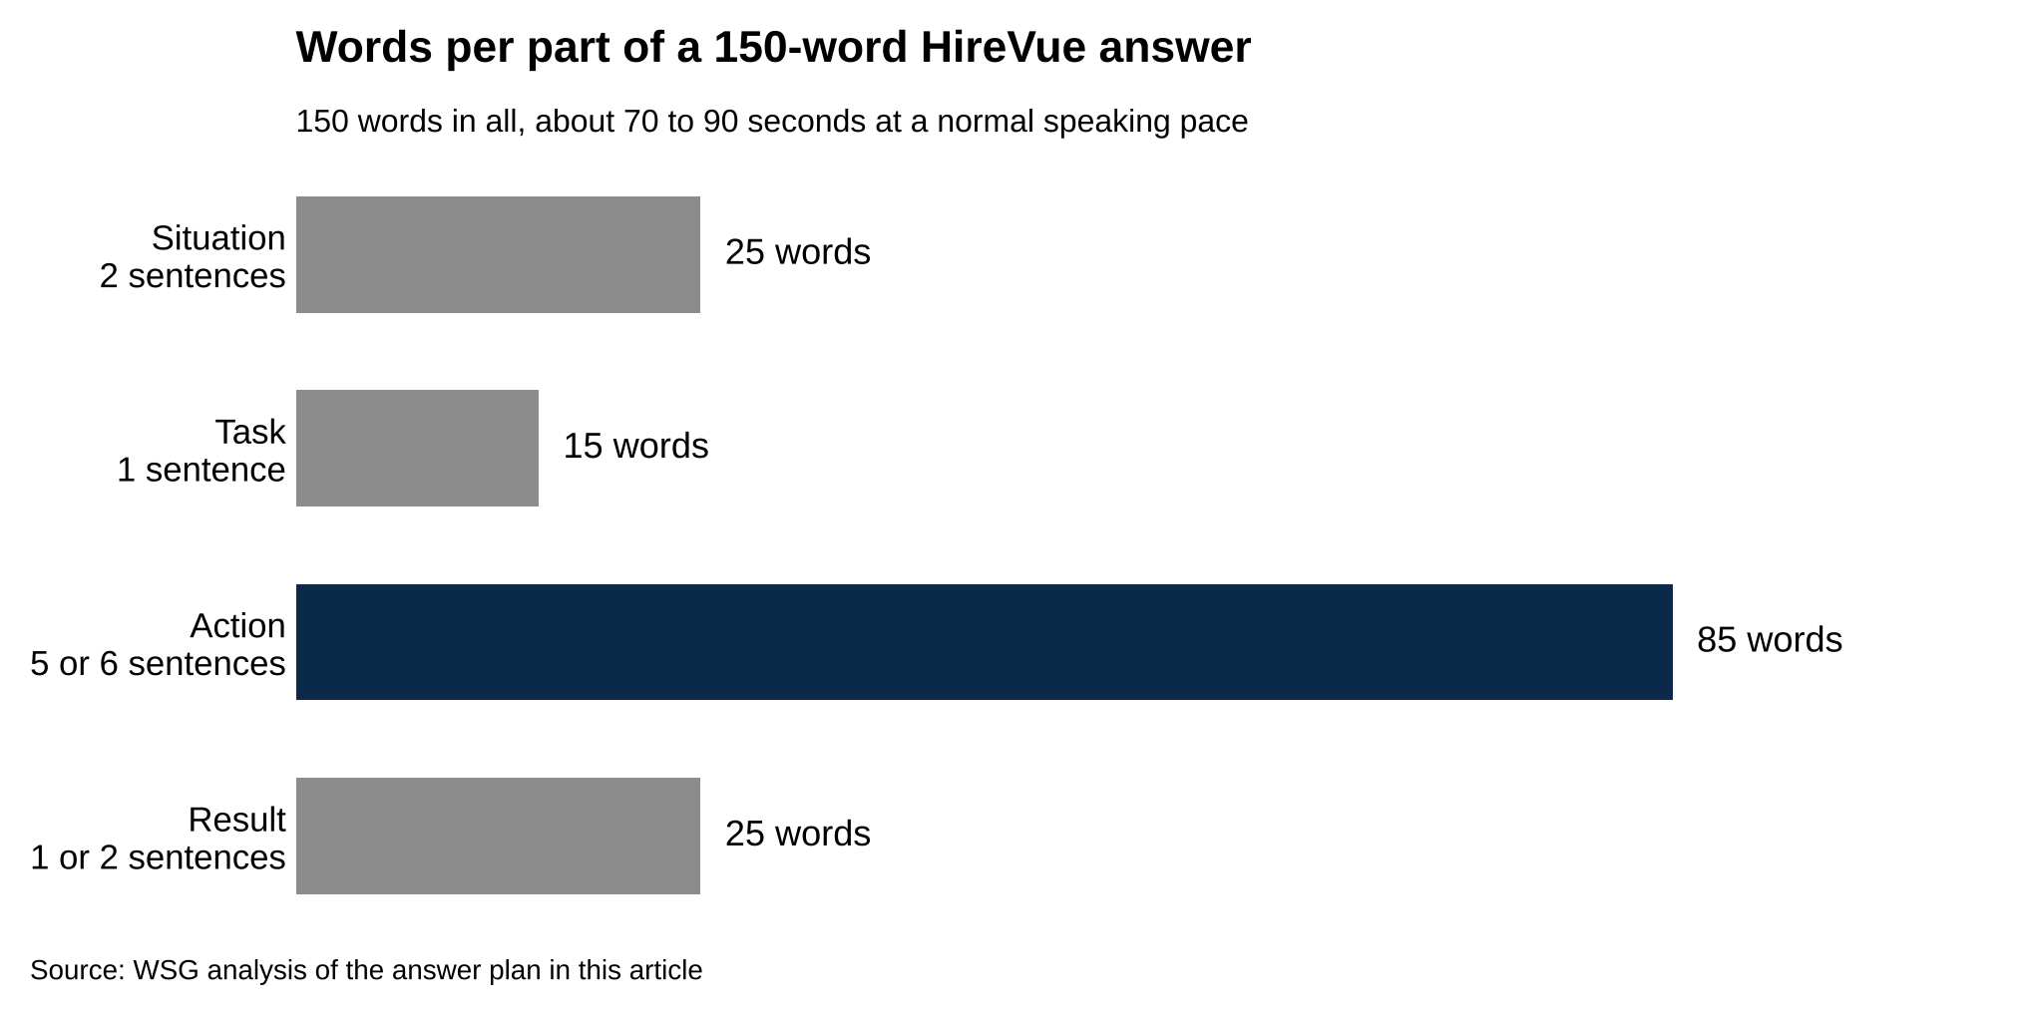
The action gets around 85 of the 150 words; situation, task and result share the other 65.
Source: WSG analysis of the answer plan in this article.

Press "Start Recording" early when you're ready, because the prep clock is a maximum and silence while it runs down gains nothing. Press "Done Answering" when you've said the result. The reviewer sees a finished answer either way.

Goldman's two-minute clock is a hard cutoff: the recording submits on its own when time runs out, mid-sentence or not. HireVue builds every bank's interview that way. What the reviewer gets is whatever was said before the clock hit zero, so an answer that saves the result for the last ten seconds risks losing the only part that mattered. Say the result early if you're unsure of your pace, then fill in the action.

On retakes, read the attempts screen and believe it. Goldman recruiters called the interview "one-and-done" in 2018, one attempt per question with unlimited practice beforehand, while a prep site's 2026 guide reports one to three retries, which is why the screen is the only reliable source. JPMorgan allowed three attempts in 2018 and one optional retry in 2026, and prep guides for Goldman and Morgan Stanley say a retry deletes the first take. [VERIFY: attempt counts per firm for the current cycle] Use a retake only when something broke: you froze, the dog barked, the connection stuttered. Keep a first take that was fine. The second take tends to sound rehearsed, and the first one is gone the moment you start it.

6. Setup that reads well on a recruiter's screen
The recording is 480p.

That's standard definition, well below what a phone records, and HireVue's technical specifications list 350 kbps as the recommended connection speed to go with it. A new webcam adds nothing a reviewer can see. Light and framing do all the work.

Put your light in front of you, the camera window at the top center of the screen, and the lens level with your eyes. HireVue's own interview tips page says to put your light source in front of you because "lighting from behind makes it hard to see you." A window behind you turns you into a silhouette at 480p. A lamp or a window in front of you, slightly above the lens, does the opposite.

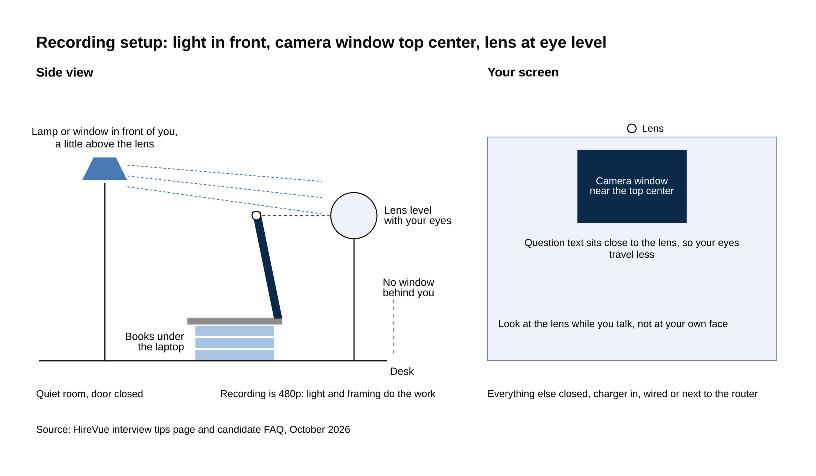
Light in front, camera window at the top center of the screen, lens level with your eyes, quiet room.
Source: HireVue interview tips page and candidate FAQ, October 2026.

The camera window goes "near the top center of your screen," per HireVue's candidate FAQ, because that's where your eyes will drift when you read the question, and the closer the question text sits to the lens the less your eyes travel. Goldman recruiters told eFinancialCareers in 2018 to put the camera level with your eyes. On a laptop that means a stack of books under it; a laptop flat on a desk looks up at you. Then look at the lens while you talk, not at your own face. HireVue's help center says "looking at your webcam while speaking gives the feeling of eye contact to the person on the other end." Its marketing page says just to be natural. Follow the help center, because natural on a webcam reads as looking down.

Room: HireVue's tips article says "a quiet, distraction free area helps you give the best impression possible." Close the door, tell whoever you live with, and record when the building is quiet.

Device: HireVue supports Windows 10 or newer and macOS 10.12 or newer, with the latest Chrome recommended and Firefox, Edge and Safari 15 or newer supported. "Chromium devices are not supported," so don't plan on a Chromebook. There's a "HireVue for Candidates" app for iOS 13 and up and Android 8.0 and up; the FAQ at the end covers when to use it. Close everything else, plug in the charger, and use a wired connection or sit next to the router.

Dress: HireVue's help center says to wear "exactly what you would for a traditional face-to-face interview." Goldman recruiters in 2018 said business casual. [VERIFY: current dress guidance from Goldman recruiters] A collared shirt or a plain top reads cleanly at 480p; fine patterns shimmer.

Notes: HireVue's tips page says you "can even keep your notes next to you in case you need a reminder during the interview." Goldman's recruiters said they don't want candidates "reading from hidden notes or uttering scripted answers," and a Bentley University career guide warns that depending on notes "will be absolutely obvious" and leads to "speaking robotically." The reconciliation is one index card below the camera with your five story names, your news story, and one line for why this firm. Never a sentence, because a sentence gets read, and a reviewer watching your eyes drop and track left to right knows exactly what you're doing.

7. A one-week plan from the invitation
How long you have depends on the bank, and the gap between applying and the invitation does too. Here's what candidates and prep guides report. [VERIFY: invite timing and windows by firm for the current cycle]

- Goldman Sachs: the invitation arrives about a week after you apply, you get about a week to complete it, and recruiters told eFinancialCareers in 2018 that a response comes in about two weeks.
- JPMorgan: the invitation can arrive within hours of applying (one September 2026 Glassdoor report said two to three hours), you get seven days, and superday invitations have followed about two weeks after recording.
- Morgan Stanley: 48 to 72 hours to complete.
- Citi and Bank of America: about 48 hours.
- Wells Fargo: from the next day to about a week.
- Deutsche Bank: the invitation comes about six weeks after applying, per its own page.

Goldman's invitation usually arrives about a week after you apply and gives you about a week to complete it, while JPMorgan's can arrive within hours and gives you seven days. The lesson is to have the five stories written before you submit any bulge-bracket application, because a JPMorgan link in your inbox two hours after you apply is a seven-day clock that started without you.

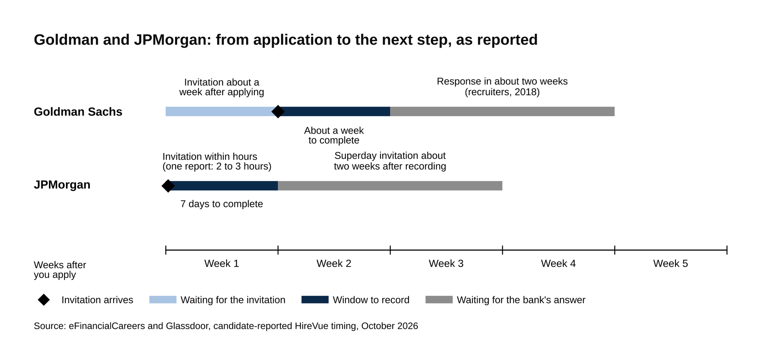
A JPMorgan link can arrive within hours of applying; Goldman's takes about a week.
Source: eFinancialCareers and Glassdoor, candidate-reported HireVue timing, October 2026.

Here's the week, assuming a seven-day window. The 48-hour version follows.

Day 1, the day the email arrives: read the deadline and its time zone, and put it in your calendar a day early. Open the link and go as far as the attempts screen, which takes five minutes and shows you the question count, the total length and the number of attempts. Don't press "Start Now."

Day 2: write. Five stories in bullet form (team, failure, conflict, led, data to decision), a four-sentence "why this firm" that names a group and a reason tied to something you've done, a three-sentence "why this division," and the news story from Section 4 with its mechanism and your view. Write bullets, not scripts. A script gets memorized and sounds it.

Day 3: record on your phone. Thirty seconds of prep, then 90 seconds of answer, for each of the stories and the motivational questions. Count the words in a transcript app if you want the number; if you're over 190, cut. Watch each one once. The things to fix are the ones you'd notice in someone else: a long setup, a result that never comes, eyes on the screen instead of the lens.

Day 4: HireVue's own practice questions, in the real room, at the time of day you'll record, in the clothes you'll wear. Three generic questions, unlimited repeats, never submitted. This is the only rehearsal that uses the real clock and the real countdown, so do it until the three-second countdown stops surprising you.

Day 5: record the real thing. Morning, before the building wakes up. Phone on silent and in another room, door closed, charger in, everything else quiet. Read the attempts screen once more. Then go.

Days 6 and 7 are the buffer, which you now don't need, and which exists because a connection drops or a roommate comes home or you wake up with a cold.

The 48-hour version at Citi or Bank of America compresses the same steps. Day 1: equipment check and attempts screen, write the stories and the news answer, record three practice answers on your phone and watch them. Day 2 morning: HireVue's practice questions in the real room, then the real interview straight after, while the setup is still in place. The stories are what take the time, which is why they get written before you apply and only revised in the window.

Say this, don't say that
Why this firm?

Don't say: "Goldman Sachs is a global leader in investment banking with a strong culture and great people, and I think I'd learn a lot here."

Say: "I want the healthcare group here. The stock pitch I spent last spring on was a medical device company, and the part I couldn't do from the outside was figure out what a buyer would pay for it. I want to sit on a team that does that for real."

Tell us about a recent piece of news that affects this division.

Don't say: "I read that the markets have been volatile lately, which affects investment banking because deals are harder to do."

Say: "The story I've followed is where interest rates go next. For leveraged finance, a lower rate cuts the interest a sponsor pays on the same loan, so the same company supports more debt and more buyouts get financed. The question I'd want to ask the desk is how long that lasts if the cuts stall."

Tell me about a time you failed.

Don't say: "I'm a perfectionist, so my biggest failure is probably caring too much about getting things right."

Say: "I ran the fundraising for our club's spring conference and missed the target by about a third, because I sent sponsor emails in March for an April event. The next year I started in November, and we covered the budget by February. The lesson was that the ask has to land before the budget cycle, not after."

Why investment banking?

Don't say: "I've been passionate about finance since I was young, and investment banking is the best place to learn."

Say: "I want to learn how companies get valued when real money changes hands, and banking is the job where you do that every week for different businesses. My internship last summer was in corporate finance at one company, and I kept wanting to see the deal from the other side of the table."

Tell me about a time you disagreed with a teammate.

Don't say: "We had some disagreements, but we worked through them and it was a great learning experience for everyone."

Say: "On our student fund team, my co-analyst wanted to pitch at a price target 20 percent above mine. I asked him to walk me through his growth assumption, found we were using different years for revenue, and we rebuilt the model together. We pitched at a target between the two and the fund took the position."

Frequently asked questions
Can I get more time on a HireVue question?

Yes, through HireVue's accommodations link, and the request goes in before you start. HireVue's ADA article says to select "Click here to request accommodations" on the first page of the interview, then "Request Additional Time" in the Timed Questions pop-up, then "Continue." Anything beyond extra time (captions, a different format) goes to the bank directly, and HireVue's FAQ says candidates who disclose a neurodiverse condition may be able to ask for the interview questions in advance.

Can I take a HireVue on my phone?

Yes. The "HireVue for Candidates" app runs on iOS 13 and up and Android 8.0 and up, and some invitations send you there. A laptop on Chrome is still the better choice, because the screen is bigger, the question text sits closer to the lens, and the frame doesn't move. If you use the phone, prop it at eye level against something that won't slide and don't hold it.

What happens if my internet drops in the middle?

Reopen the invitation link. HireVue returns you to your last unanswered question, so the answers you finished are saved. If the connection dropped in the middle of an answer, that answer may have submitted as it was, and HireVue's support team can't reset it. Email the bank's campus recruiter the same day, say which question was cut and why, and ask whether a new invitation is possible. Only the bank can send one.

What to do today
If the email is already in your inbox, find the deadline and open the link as far as the attempts screen. Then close it and write the five stories, because they're the only part of this that takes real time. The clocks, the countdown, the camera and the retake rule are the same at every bank, and learning them takes an afternoon.

If you haven't applied yet, write the stories now and keep them in a file. The invitation at JPMorgan can arrive two hours after you submit. Our round-by-round guide to the Goldman Sachs Summer Analyst interview covers what comes after the HireVue, and the JPMorgan superday post covers the round that follows at the other bank most likely to send you a link this week.

